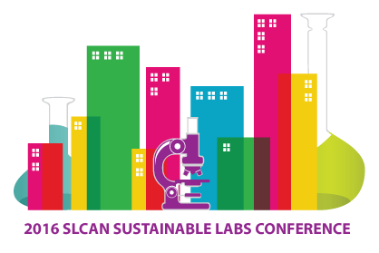

Sponsor and Exhibitor Participation Form
Complete this form and return to info@slcan.ca.

√
Networking Event | $4,000

Program | $3,000
Audio-visual | $3,000
Name Badge | $2,000

Luncheon | $1,000 each (2 Available)
Breakfast | $500 each (2 Available)
Refreshment Break | $300 each (4 Available)

Exhibit Booth | $1,000
TOP THREE BOOTH CHOICES 1. ______ 2. ______ 3. _______
*Prices do not include tax. An invoice will be emailed to you within two business days.
Payment is due by November 1, 2016.

Contact Information Invoicing Information (if not the same)
Company/Department:_________________________  Contact Name:_______________________________  Mailing Address:_____________________________ ___________________________________________  Email: _____________________________________  Tel:________________________________________ | Company/Department:_________________________  Contact Name:_______________________________  Mailing Address:_____________________________ ___________________________________________  Email: _____________________________________  Tel:________________________________________

